

|  |  |  |  |  |  |  |
| --- | --- | --- | --- | --- | --- | --- |
|  | | |  | | | |
| REPORT FOR: | | CABINET | | | |
| Date of meeting: | | 20 June 2019 | | | |
| Subject: | | Revenue and Capital Outturn 2018/19 | | | |
| Key Decision: | | Yes | | | |
| Responsible Officer: | | Dawn Calvert, Director of Finance | | | |
| Portfolio Holder: | | Councillor Adam Swersky, Portfolio Holder for Finance and Resources | | | |
| Exempt: | | No, except for Appendix 5, which is exempt on the grounds that it contains “exempt information” under paragraph 3 of Part I of Schedule 12A to the Local Government Act 1972 (as amended) in that it contains information relating to the financial or business affairs of any particular person (including the authority holding that information) | | | |
| Decision subject to Call-in: | | Yes | | | |
| Wards affected: | | All wards | |
| Enclosures: | | Appendix 1 - Revenue Carry Forward Schedule 2018/19  Appendix 2 - Capital Receipts Flexibility Strategy 2018/19  Appendix 3 - Movement in Reserves 2018/19  Appendix 4 - 2018/19 MTFS Savings Tracker  Appendix 5 - Commercialisation Update 2018/19 Qtr 4  Appendix 6 - Capital Outturn and Funding 2018/19 | | | |
| Section 1 – Summary and Recommendations | | | | |
| This report sets out the Council’s revenue and capital outturn position for 2018/19.  **Recommendations:**   1. That Cabinet notes the revenue and capital outturn position for 2018/19 as summarised in paragraphs 1 to 1.2.      1. That Cabinet notes the movement between reserves as summarised in table 4, paragraphs 2.31 to 2.44. 2. That Cabinet notes the revenue carry forwards as summarised in table 5, paragraph 2.45, that have been approved under delegated authority by the Director of Finance. 3. That Cabinet notes the slippages on the Capital Programme, summarised in tables 9 and 10 that have been approved under delegated authority by the Director of Finance for carry forward into 2019/20. 4. That Cabinet note the Quarter 4 Commercialisation Update as specified in Appendix 5 (Part II report).   **Reason (for recommendation)**  To report the final position for the financial year 2018/19 | | | |

# Section 2 – Report

**EXECUTIVE SUMMARY**

1. The revenue outturn position for the Council’s General Fund at the end of the financial year 2018/19 year shows a balanced position after transfer to reserves. The Council has been working towards a planned underspend of at least (£2.2m) to support the 2019/20 budget. Through robust financial management the planned underspend has been achieved and increased to (£3.110m).

* + 1. The balanced budget position assumes total revenue budget carry forward of £2.385m, which is added to reserves in 2018/19 for use in 2019/20.

1. Total spend on the Capital Programme for the year is £57.783m against a budget of £217.565m, giving a variance of £159.782m. The variance of £159.782m is made up of total slippage of £93.616m which will be carried forward into 2019/20 and underspends of £66.166m. Of this under spend; £1m will be set aside as Council Wide Capital Budget in 2019/20 and the balance of £65.166m will be removed from the programme.
2. **REVENUE OUTTURN**

The Council’s net position after a net Directorate overspend of £3.429m and Corporate adjustments is an (£8.603m) underspend. Of this, (£4.279m) relates to the 2018/19 Business Rate Pool income and additional sec 31 grant which is built into the 2019/20 budget. The balance of (£1.214m) is additional income, received at the end of the financial years from the Business Rate Pool as a result of additional business rate growth across London over and above that estimated. This leaves a net underspend of (£3.110m). The (£2.2m) planned underspend is transferred into the Business Planning Reserve and will be applied to support the 2019/20 budget. The additional underspend of (£0.910m) is transferred into the Commercialisation Reserve.

2.1 Table 1 below sets out the Summary Revenue Outturn position

**Table 1: Revenue Outturn 2018/19 Summary**



**Directorates’ Outturn**

2.2 The outturn for the Directorates is a net over spend of £3.429m after taking into consideration carry forwards of £1.546m. The position for each directorate is summarised as follows**:**

**Resources**

1. The outturn position for Resources is an under spend of (£0.201m) after allowing for a carry forward of £1.080m. The key reasons for the under spend are detailed below:

● The Management Team is showing a net (£0.101m) underspend which represents the savings realised on the delayed recruitment to the Corporate Director of Resources position.

* The Finance division is reporting a net (£0.200m) underspend, which largely relates to reduced insurance premiums for the authority and a number of other minor variances. This underspend is after allowing for a transfer into an Investment Property Reserve of £0.200m to cover any potential income shortfalls from investment properties.
* Human Resources are reporting a net (£0.149m) under spend, which largely relates to a lower level of spend on Learning and Development and Organisational Development.
* Legal and Governance are reporting an overall net (£0.882m) under spend due to a higher than anticipated demand for Land Charges, Registration and Legal Services and a small underspend in Members’ Allowances. The underspend is after allowing for a transfer into reserves of £0.716m to cover any potential shortfalls in income from the existing shared service arrangements with other Local Authorities.
* The Procurement and Commercialisation service is reporting a net (£0.140m) under spend which relates to savings on staff costs and efficiencies.
* Other under spends across the services of (£0.073m).

2.4 The above are partly offset by a number of over spends:

* The Business Support division is reporting a net overspend of £0.162m which results from increased amounts of outbound post and the initial set up costs of the new hybrid mail process.
* Customers Services are reporting a net £0.890m over spend which mainly relates to the write off back to revenue of £2.7m for a Corporate IT Capital project.
* The Strategic Commissioning division is reporting a net overspend of £0.292m due to unachieved MTFS savings targets combined with the increased income target in relation to Communication services and Commissioned work.

The recommended carry forward requests of £1.080m are set out in Appendix 1

**Community**

2.5 The outturn position for Community is an over spend of £0.834m after taking into consideration £0.323m carry forward and the establishment of a vehicle Fund reserve to smooth the cost impact of vehicles maintenance contract over the medium term.

* 1. There is an adverse variance of £0.487m in **Environment & Culture,** which is attributable to a number of factors. The key reasons for the over spend are detailed below:

●Public Protection £0.220m**:** The adverse variance is mainly due to a shortfall in Licensing Income of £0.150m and Health & Safety SLA income of £0.050m as a result of a reduced take-up from schools.

* Waste Management £0.147m: There is an unachieved MTFS saving of £0.075m profiled in 18/19 for the route optimisation of Food Waste collection. Although the initiatives in relation to food waste collection are being progressed as part of Waste Review, the saving planned to be achieved in the latter part of the financial year was offset by the additional costs from other proposed changes within the review. Staffing cost was overspent by £0.075m due to the use of agency staff and overtime payments. There was also an underachievement of income from sale of recyclable materials but this was mitigated by the under spend on waste disposal.
* Street & Grounds £0.033m: The adverse variance is due to the underachieved grounds maintenance Service Level of Agreement (SLA) income of £0.094m, partly mitigated by an under spend in supplies & services budget.
* Divisional Director (£0.030m):The favourable variance is due to an under spend in staff training and recruitment budget.
* Culture Service over spend by £0.117m: This is due to the unachieved 2017/18 MTFS in relation to the redevelopment of Harrow Leisure Centre £0.100m and libraries budget shortfall. The Museum Service had an adverse variance of £0.049m due to income shortfall in facilities hire. The full year impact of the new charges implemented for all new bookings at the Great Barn since July 18 and a marketing strategy for the Great Barn developed and implemented during the year are expected to be realised in 2019/20. The adverse variance in the Museum Service is mitigated by an over achievement of income in Harrow Arts Centre and the Music Services.
  + 1. There is an adverse variance of £0.657m in **Commissioning & Commercial Services**, which is made-up of the followings:
* Business and Commercial £0.065m: Overspend on third party payments for the delivery of commercial projects.
* Catering Services £0.141m: Underachievement of income of £0.013m and overspend on agency staff cost of £0.109m.
* Parking Services £0.193m: Overspend on staffing costs of £0.230m, due to one-off payment in relation to severance and the use of agency staff for sickness cover, is partially mitigated by a higher than budget forecast parking income of £0.037m.
* Facilities Management £0.831m: Overspend on corporate cleaning and building maintenance budget of £0.438m, due partly to the impact of early termination of the cleaning contract that resulted in additional costs following the services returned in-house. Schools Cleaning SLA account’s total adverse variance was £0.625m which consists of an unachievable income target of £0.305m and a deficit of £0.320m. These are partially offset by an over recovery of rent and underspend on premises related costs at the depot.
* Transport £0.081m: Unbudgeted third party payment relating to bus routes review and overspend on agency staff costs.
* These pressures are partly mitigated by an overachievement of income in Network Management for Street works Permit (£0.177m) and rent income in Corporate Estates (£0.044m), underspend on staff costs in Community Engagement due mainly to vacant posts (£0.116m), and the benefit of capitalisation of appropriate costs including Highway Improvement Works cira (£0.317m).

1. There is a favourable variance of (£0.159m) in **Regeneration, Enterprise and Planning**, attributable to an under spend on staffing and a net overachievement of planning income.
2. The revenue costs of the Regeneration Programme (£1.282m) are funded from capacity already set aside and £1.7m of this capacity remains available for 2019/20.
3. **Housing General Fund** shows an under spend of (£0.151m) due mainly to an over achievement of MTFS savings associated with the Property Acquisition Programme. As a result there has been no requirement to draw down on the Flexible Homelessness Support Grant for 2018/19 which will be carried forward to 2019-20.
4. The recommended carry forward requests of £0.323m are set out in Appendix 1.

**People Services**

1. People Services is reporting a gross over spend of £2.796m after taking into consideration a carry forward of £0.143m. This is reduced to an over spend of £1.220m after one off Social Care grant income of £1.576m.
2. The net over spend of £1.220m is made up of an over spend of £2.821m on Adults, an under spend of (£0.251m) on Public Health Service and an under spend of (£1.350m) in Children’s Services as detailed below.

**Adult Services**

1. Adult Services is reporting a gross over spend of £4.397m which is reduced to £2.821m after applying one off Social Care grant income of (£1.576m):

* There is an over spend of £2.360m on adult social care which is due to:
* Adult placement cost over spend of £3.838m accounting for increased complexities and an increase in discharges from hospital into adult social care.
* £0.098m is the children and young adults with disabilities overspend.
* The over spend has been reduced by one off grant income of (£1.576m).

• Other Adults – an over spend of £0.103m is due to the following;

* £0.122m in relation to Mental Health services managed by Central North West London (CNWL).
* Increased staffing costs of £0.072m as a result of transitioning to the new structure.
* £0.123m is due to contractual arrangements in relation to mental health accommodation services, including Look Ahead of £0.060m.
* A lower level of equipment charged to revenue (£0.214m) resulting in an under spend.

• Strategic Management – an over spend of £0.383m - This variation represents costs in relation to transformation projects not drawn down from the transformation reserve.

• In-house provisionsare underspent by (£0.024m).

**Children’s Services**

1. The under spend for the division is (£1.350m), after accounting for a carry forward of £0.143m. Of this (£1.350m) under spend, £0.450m was already earmarked to contribute towards corporate management actions.
2. The main variances in the 2018/19 Children’s services outturn are listed in table 2 below:

**Table 2: Children’s Services Variance**

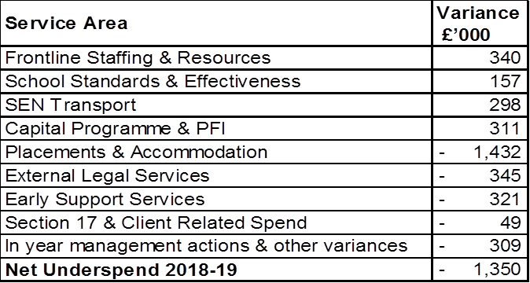

1. The main areas of under spend are:

* Children’s Placement and Accommodation (£1.432m) under spend.

Since the start of the financial year there has been a projected underspend on this budget as a result of the full year effect of reductions and planned actions undertaken in 2017/18 to reduce the commitment on this budget.

In 2018/19 the placement costs have continued to reduce throughout the financial year mainly to a fewer number of children needing services. The rate of children looked after per 10,000 of the child population in Harrow is currently one of the lowest in London. This has been achieved partly through the work of the Keeping Families Together service which aims to prevent young people from coming into care or stepping young people down from care where it is safe to do so. There are regular resource tracking and monitoring panels to ensure the level of accommodation and cost continues to be appropriate for the young person’s needs. This includes targeted actions to reduce the average cost of service provision through negotiation with providers. In addition, the overall cost reduction of accommodation for unaccompanied asylum seeking children has been achieved through maximising the young people placed within block contract services and council properties.

* External Legal Services (£0.345m) under spend

The expenditure relates to external legal fees for care proceedings including counsel, court fees, experts and assessments. The underspend is due to an increase in the number of Public Law Outline (PLO) pre proceedings work to ensure that as much work has been carried out as possible before or instead of the beginning of care proceedings as well as carrying out any necessary assessments and work with the family which may either delay or incur additional costs once the care proceedings have begun. In addition to this the reduction in the number of children looked after will result in fewer court proceedings.

* Early Support Services (£0.321m) under spend

The under spend of (£0.321m) is mainly because of difficulties in recruiting qualified staff into vacant roles despite a number of recruitment drives during the course of the year. However, a number of key management posts have now been recruited to and recruitment will continue to ensure all remaining essential posts are filled.

* Section 17 and Client Related Spend (£0.049m) under spend

Expenditure relates to families being supported by the Council because they have no recourse to public funds (NRPF) and also provides support and subsistence payments to children in need. Regular tracking & monitoring enables decisions for families to be made in a timely way to enable access to benefits.

* In Year Management Actions and Other Variances (£0.309m) underspend

This is made up of other management actions in relation to one off income.

1. The above under spend is reduced by the following over spends:

* Frontline Staffing and Resources £0.340m over spend

The main pressure is as a result of agency staff covering vacant posts, sickness and maternity together with ‘as and when’ required staff carrying out supervised contact. There have also been additional pressures on non salary costs relating to severance following a reorganisation; recruitment fees, staff expenses, training and IT/phone equipment charges.

* School Standards & Effectiveness of £0.157m over spend

This being due to one off severance costs as a result of a restructure to move the service from a traded service to a statutory service, shortfall in income and agency staffing costs to cover vacant posts.

* SEN Transport £0.298m overspend

SEN Transport provides home to school and home to further education settings for children and young people in education with Education Health and Care Plans (EHCPs).The outturn position has been mainly due to increase in service demand. In particular there has been has been a marked increase in the number of young people eligible for transport in the post 16 and post 19 phases, the latter of which results in transport being provided for a cohort of young people who previously did not receive a service. There has also been increase in agency staffing costs to cover driver vacancies.

* Capital Programme & Schools Private Finance Initiative £0.311m

This is as a result of a contribution to the PFI sinking fund to ensure the PFI contract is affordable in future years and a provision for external legal and technical advisors to resolve the outstanding capital programme contractual issues.

1. The recommended carry forward requests of £0.143m are set out in Appendix 1.

**Dedicated Schools Grant (DSG)**

1. The Dedicated Schools Grant (DSG) is a ring-fenced grant of which the majority is used to fund individual school budgets in maintained schools, academies and free schools in Harrow. It also funds Early Years nursery free entitlement places for 2, 3 and 4 year olds in maintained council nursery classes and private, voluntary and independent (PVI) nurseries as well as provision for pupils with High Needs including those with Education Health & Care Plans (EHCPs) in special schools and special provision and mainstream schools in Harrow and out of borough. The DSG is split into blocks: schools block, early years block and high needs block. The summary of the budget is detailed in table 3 below:

**Table 3: Dedicated Schools Grant (DSG) Budget**

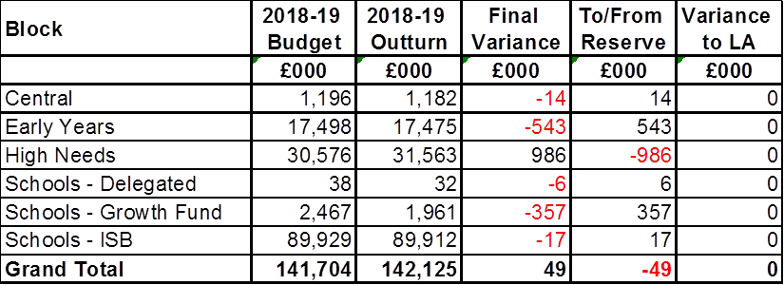

1. Explanation of the main areas of under spend are detailed below:

* Schools Block

In 2018-19 the government introduced a new National Funding Formula (NFF) for Schools, High Needs and the Central Schools Services Block. For the Schools Block this means that LAs are funded on the basis of the total of the national funding formula for all schools, academies and free schools in its area. However the final formula for distribution is determined by each Council following consultation with schools and Schools Forums. This funding is distributed to mainstream schools, academies and free schools in Harrow.

* Early Years Block

Funding for Early Years relates to free 15 hour nursery entitlement for all 3 and 4 year olds in maintained nurseries and nursery classes as well as private, voluntary and independent providers (PVI). From September 2017 this was extended to 30 hour nursery entitlement for eligible 3 and 4 year olds. It also funds free 15 hour nursery entitlement for disadvantage 2 year olds. Funding is distributed to providers via a formula for 3 and 4 year olds which calculates a universal hourly rate based on participation, deprivation as determined by the child’s postcode and quality and flexibility of provision. Funding for 2 year olds is distributed to providers via a fixed hourly rate based on participation. There is an overall underspend of £0.543m due to fewer claims for funding from providers and additional funding allocated in year as a result of updated pupil numbers on the January 2018 census.

* High Needs Block

High Needs funding is designed to support a continuum of provision for pupils and students with special educational needs (SEN), learning difficulties and disabilities, from their early years to age 25. The following are funded from the High Needs Block:

* + - Harrow special schools & special academies
    - Additional resourced provision in Harrow mainstream schools & academies
    - Places in out of borough special schools and independent special schools
    - Education Health & Care Plans (EHCPs) in mainstream schools & academies
    - Post 16 SEN expenditure including Further Education settings
    - SEN Support services and support for inclusion
    - Alternative provision including Pupil Referral Units and Education Other than at school

The High Needs Block budget is £30.576m after recoupment of place funding for academies/free schools and post 16 institutions and including the 0.5% transfer from the Schools Block agreed for 2018-19 and the additional High Needs funding announced by the Government in December 2018 (£0.606m in 2018-19 and 2019-20). The final outturn is an over spend by £0.986m.

* In 2018-19 the High Needs Block budget has been calculated using the new High Needs National Funding Formula which came into effect from April 2018. The High Needs Block National Funding Formula in 2018-19 has generated funding which is £2.9m lower than the actual budget allocated to High Needs in 2017-18. This is partially due to the fact that the 50% of the overall allocation is based on previous years’ HNB allocations, rather than the actual spending on HNB. In 2018-19 this will be funded by an historical contingency managed by Schools Forum.
* There are significant pressures across London boroughs on the DSG attributed to in the main by a shortfall within the High Needs Block. In 2019-20 there is also predicted to be a shortfall in this budget. The LA has a statutory duty to make provision for children and young people with Special Educational Needs and Disabilities. It is recognised that the number of children and young people who require and are entitled to these services, as well as the price of those services, are increasing at a rate that outstrips the funding made available under current formulas.
* In 2019-20, there will be an over spend on this budget which will be carried forward into the next or subsequent years. A 3 year recovery plan will be required by the DfE. Plans are continuing to be developed to discover ways to be more efficient on spending on services for children and young people with Special Educational Needs and Disabilities, in particular focusing on increasing certain provision within the borough and thereby reducing the council’s reliance on expensive out-of-borough provision.
* For Harrow there has been an increase in the HNB budget since 2013 of £5.128m (21%) compared with an increase in HNB spend of £8.090m (34%) over the same period and increase in Education Health and Care Plans from 1,168 January 2014 to nearly 1,700 October 2018 (46%).

1. A recent survey showed that London boroughs had a total shortfall of £78m in 2017-18 compared with high needs allocations, with 32 out of 33 boroughs reporting a shortfall. 29 boroughs had a shortfall of over 1% of their high needs allocations. With allocations only increasing by 2.3% in 2018-19, and transfers of resources between DSG blocks now capped at 0.5%, councils will be increasingly reliant on using reserves and general funding to meet this shortfall, as well as carrying forward DSG deficits.

Growth Fund

1. £1.565m was earmarked for schools taking expansion classes from September 2018. Included in this budget was also a contingency for additional bulge classes in other year groups. The underspend relates to clawback of bulge class funding where the bulge has moved out the top of the school and additional in year bulge classes that were not required this financial year.

**Public Health**

1. Public Health is reporting an under spend of (£0.251m) after making a contribution to the specific public health reserve of £0.425m. The in-year underspend reflecting the main a lower level of expenditure in relation to sexual health services representing the full year effect of the contract re-procured during 2017/18, and enables an increase in the funding of the wider determinants of health.

**CORPORATE ITEMS**

**Corporate Items**

1. Corporate items underspent by (£1.716m) as follows:

* (£0.058m) under spend against the £0.400m budget to fund the Apprenticeship levy.
* (£0.768m) write back on the Good Received Invoice Received suspense account.
* (£0.307m) is due to the 2018/19 Employer’s contribution adjustment which is a result of over recovery of pension contributions.
* (£0.085m) is the net reduction in subscription charges paid in the year.
* (£0.041m) underspend on external audit fees.
* Other under spends on corporate items including Pension Augmentation (£0.457m).

**Contingency**

1. There has been no call on the (£1.248m) contingency for unforeseen items this year.

**Technical and Corporate Adjustments**

1. The variance of (£8.818m) on Technical and Corporate Adjustments after allowing for a carry forward of £0.839m is a detailed as follows:

* Net under spend of (£1.033m) against inflation provisions not drawn down.
* Underspend of (£0.056m) increases in NNDR revaluations.
* Underspend of (£0.526m) against a revenue contingency set aside for unforeseen circumstances not utilised.
* (£0.264m) under spend against the provision for litigation was less than budgeted for.

1. Additional grant income of (£6.197m) was received after the budget was set:

* (£4.279m) funding from the 2018/19 Business Rate Pool and additional one-off Section 31 funding, which is built into 2019/20 budget.
* Based on the revised number from the London Pool Pilot in March 2019, Harrow has received an additional (£1.214m) in respect Business Rate Pool and Section 31 funding.
* (£0.599m) Levy Account Surplus that was announced in December 2018 as part of the 2019/20 financial settlement.
* (£0.105m) of grant received from Central Government to fund the local authority’s preparation for the EU exit.

1. There has been a net underspend of (£0.742m) on capital financing due to slippages and underspends against the Capital Programme. This underspend is after allowing for a transfer of a £4m voluntary MRP provision into the revenue account, which has been transferred into the Transformation Reserve.

**Capital Receipts Flexibility 2018/19**

1. The budget assumed applying £2.7m of capital receipts to Capital Flexibilities. The value actually applied was £1.200m, creating capacity for of £1.5m to be applied in future years. A detailed breakdown of the £1.200m applied is included in Appendix 2.

**RESERVES**

1. The main reserves are set out in the following table, supported by narrative. A more detailed analysis of the movement in reserves is set out in Appendix 3.

**Table 4: Movement In Main Reserves**

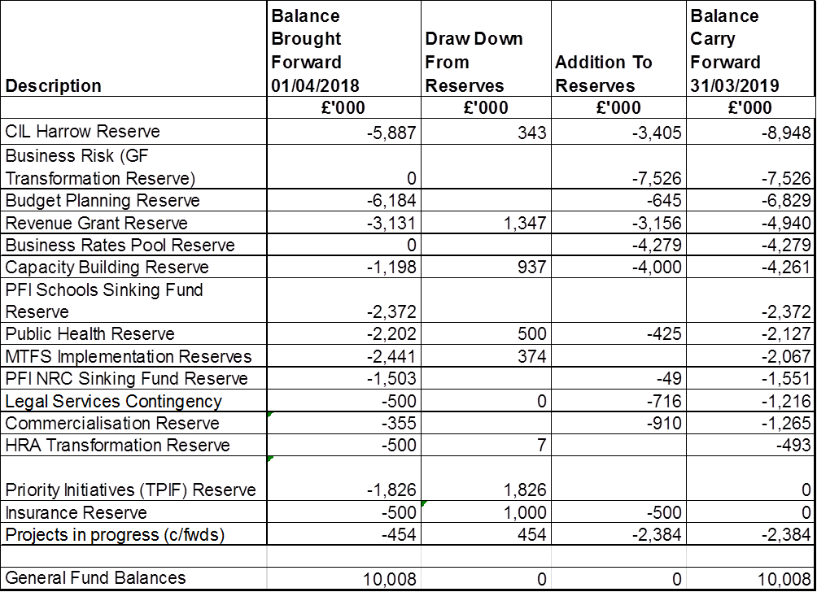

1. **CIL Harrow Reserve** – The **Community** **Infrastructure** **Levy** is a planning charge, introduced by the Planning Act 2008 as a tool for local authorities in England and Wales to help deliver infrastructure to support the development of their area. Harrow has £5.887m in the reserve as at 31st March 2019, £3.405m has been added during the year and £0.343m drawn down, giving a closing balance of £8.948m. This will be used to fund Capital Programmes in future.
2. **Business Risk/GF Transformation Reserve –** Established to cover potential shortfall/risk of achieving sufficient savings to cover future year budget gaps.
3. **Budget Planning Reserve** – The balance at the beginning of the year was £6.184m. £0.910m has been added to this reserve, which leaves a balance of £6.829m at 31st of March 2019.
4. **Revenue Grant Reserve –** This reserve holds revenue grants to be used for specific purposes or which may be subject to claw back if conditions of the grant are not met. The net contribution to this reserve in 2018/19 is £1.809m, bringing the total to £4.940m as at 31st March 2019.
5. **Business Rate Pool Reserve –** This reserve of £4.279m relates to the funding from the 2018/19 Business Rates Pool and additional one-off Section 31 funding. The full value is built into the 2019/20 budget.
6. **Capacity Building Reserve –** This reserve was set up at the end of last year 31st of March 2018 with a sum of £1.198m. £0.937m has been draw down in year and £4m added which leaves a balance of £4.261m. The 4m is ear marked for organisational transformation costs.
7. **Public Health Reserve –** This reserve relates to unspent government grant paid in relation to the delivery of public health responsibilities. The conditions which apply to the use of the ring-fenced grant also apply to unspent balances, with the Department of Health reserving the right to reduce future year allocations where underspends are considered material.
8. **MTFS Implementation Reserve –** This reserve is earmarked to facilitate the achievement of MTFS savings. The balance at the start of the year was £2.441m, £0.373m has been drawn down in the year to fund redundancy and pension strain costs, which leaves a balance of £2.067m at 31st of March 2019.
9. **Legal Services Contingency –** this reserve is a contingency to cover any possible income shortfalls from the legal shared services arrangement with other local Authorities.
10. **Commercialisation Reserve** – The balance at the beginning of the year was £0.355m. £0.910m has been added to this reserve to support future commercialisation.
11. **HRA Transformation Reserve** – The reserve balance of £0.493m will be used to fund any redundancy and pension strain implications from the proposed restructure and for the implementation of the new housing ICT system approved by Cabinet on 11th April 2019.
12. **Priority Initiatives Reserve -** The balance at 1 April 2018 was £1.826m. During the year £0.402m was drawn down from the reserve to fund both revenue and capital expenditure, and the balance of £1.424m has been transferred to the Budget Planning Reserve to support the future budget.
13. **Insurance Reserve** – The insurance reserve was established as an additional one off sum to supplement the annual insurance provision if it was needed. Based on the last few years, it is felt that the provision in the budget is adequate and this reserve has now been transferred into the Business Risk Reserve.
14. **Projects in Progress (c/fwds)** – This reserve holds the revenue carry forward requests from the 2018/19 outturn process. The carry forward requests are summarised below in table 5 and detailed in Appendix 1

**Table 5: Summary of Revenue Carry Forwards**

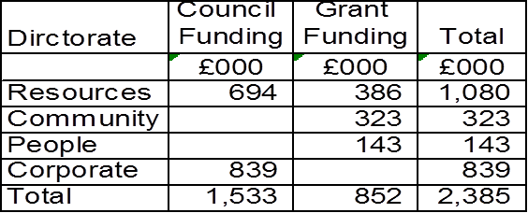

**GENERAL FUND BALANCES**

1. General Fund balances remain at £10.008m. The 3 years MTFS 2019/20 to 2021/22 assumes no use of general fund balances.

**MTFS Implementation Tracker**

1. The 2018/19 budget includes approved MTFS savings of £8.801m. The actual achievement of savings is summarised in table 6 below and shown in detail in Appendix 4:

**Table 6: Summary of MTFS Tracker**

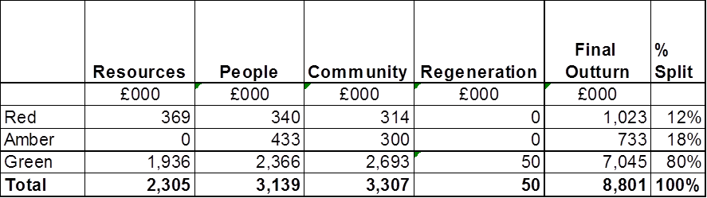

1. Of the £8.801m of savings in 2018/19, a total of £1.023m are been categorised as red savings which means they were not achieved in 2018/19. Some of these savings are red as the implementation was delayed and, although not achieved in 2018/19, will be progressed in 2019/20.

**Analysis of the Red Savings**

1. Within the **Resources** directorate £0.369m savings classified as red:

* The Strategic Commissioning savings RES_SC01 and RES_SC_02 of £0.013m and £0.107m respectively which relate to Income from Communications were not achieved. Proposals will be brought forward to create a sustainable position for Communications in the future.
* Saving reference RES15 for £0.151m for restructuring of the commercial, contracts and procurement division’s function. The saving was not delivered due to the cessation of shared service arrangement with Brent. However, the budget has been realigned across the directorate to mitigate this.
* Special Responsibility saving RES 18.19 06 of £0.058m was not achieved. The new administration has confirmed that the number of cabinet members will not change.
* Member meetings, member self-service, change to standards regime saving RES 18.19 05 of £0.040m was not achieved due to associated risks.

1. In **Community** directorate £0.314m of savings were classified as red:
   * There is one red saving in Community of £0.239m which relates to Income from expansion of Central Depot with savings reference COM. Additional income from the depot is not possible until after the new depot which provides extra office and parking spaces has been built.
   * £0.075m savings for Route Optimisation of food waste collection savings (COM_S12), now unachieved.
2. **People Services** savings of £0.340m are rated as red as follows:
3. Children’s Services – The net saving of £0.100m which was intended to be a reduction in SEN assessment and review service is now classified as red. Given the rise in demand in the number of young people with SEN, the remainder of this saving is no longer considered achievable. This will be mitigated in other areas of the directorate.
4. InAdult services**,** 2 red savings totalling £0.240m are detailed:

* Wiseworks commercialisation opportunity savings (PA_3) of £0.056m is categorised as red. The shortfall in delivery of 2018/19 income targets together with further increased income requirement has not been achieved.
* The Milmans Community tender saving reference PA_4 of £0.184m has not been achieved in 2018/19 as the community model was unsuccessful. These savings have been expected to be mitigated in full through the achievement of rental income (£0.128m in a full year) and maximisation of capacity at NRC's enabling externally funded placements to be supported through in house provision.

**Analysis of the Amber Savings**

1. The amber rating indicates that a saving was partially achieved in the year but not fully achieved. The £0.733m of amber savings (in Table 7) have been further analysed in table 7 to show how much was achieved (green) and the amount of unachieved savings (Red).

**Table 7: Analysis of 2018/19 Amber Savings**

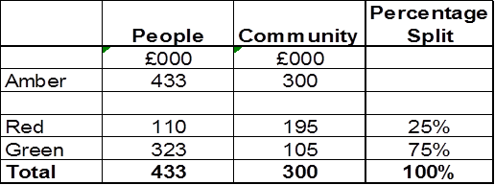

1. **Community** -Of the£0.300m savings categorised as amber in Community, the following savings of £0.195m has been re-categorised as red:

* Phase 2 of Environment & Culture Review - Regulatory Services £0.200m. The delay in the commencement of the enforcement review meant that the saving was not fully achieved in 18/19. Out of the £0.200m target, £0.050m was achieved through additional licensing income and the remaining £0.150m was unachieved in 18/19.
* £0.045m relates to the Housing Related procurement savings which result in a one-off non achievement of £0.045m.

1. **People** – The total savings of £0.433m classified as amber is made up of £0.110m red savings and £0.323m green savings. The red savings of £0.110m which are all in Adults is detailed as follows;

* £0.050 of the Restructure of Adult Social Care savings PA01 has been classified as red, driven by transition of the new structure which will be fully delivered in 2019/20.
* Of the floating support contract savings of £0.200m, £0.060m was expected to be achieved following contract award, however this has been challenging to operationalise and dialogue is on-going with the providers in relation to the contractual arrangements. It is anticipated that this will be resolved during 2019/20.

**HOUSING REVENUE ACCOUNT (HRA)**

1. Results for the HRA show a surplus of £0.198m against a budgeted deficit of £1.099m, this surplus is due to lower depreciation charges, unutilised Revenue Contribution to Capital Outlay (RCCO) due to slippage in the capital programme, lower provision for bad debts, unutilised contingencies and increased capitalisation for the Homes-4- Harrow programme, partially offset by pressures on repairs. This surplus has been transferred to earmarked reserves to support the new build programme and to offset the impacts of welfare reforms.
2. A summary of the HRA position is set out in table 8 below:

**Table 8: Summary of HRA Position**



**Commercialisation update**

1. The Commercialisation Update 2018/19 (Qtr. 4) is included as Appendix 5.
2. **CAPITAL**
3. Total spend on the Capital Programme for the year is £57.783m, which is 27% of the approved budget of £217.565m. The variance of £159.782m comprises slippage of £93.616m and an under spend of £65.166m.
4. £59.363m of the under spend relates to a planned reduction of the Regeneration capital programme that was reported to Cabinet in December 2018. After allowing for the Regeneration, the remaining underspend of £5.803m is attributable to other services. £4.603m relates to the HRA and £1.200m relates to the General Fund.
5. The £1.200m underspend on the general fund is after allowing for £1m to be set aside as a Council Wide Capital Budget in 2019/20. Further detail on the under spends and slippage is explained below. This net underspend will reduce borrowing costs and be taken into account as part of the 2020/21 budget setting process.

**Table 9: Summary of Capital Outturn**

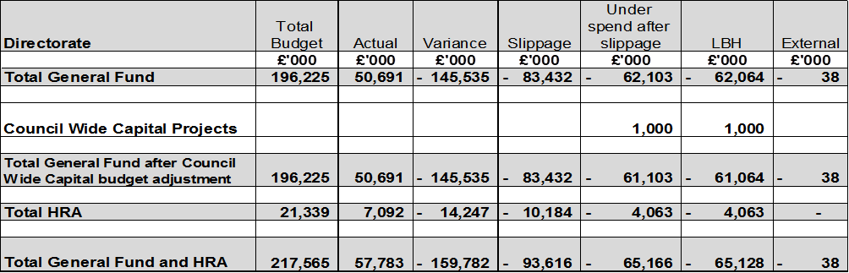

1. The slippage identified in Table 10 below and detailed in Appendix 6 has been approved under delegated authority as carry forwards by the Chief Finance Officer.

**Table 10: Capital Outturn and Funding 2018/19**

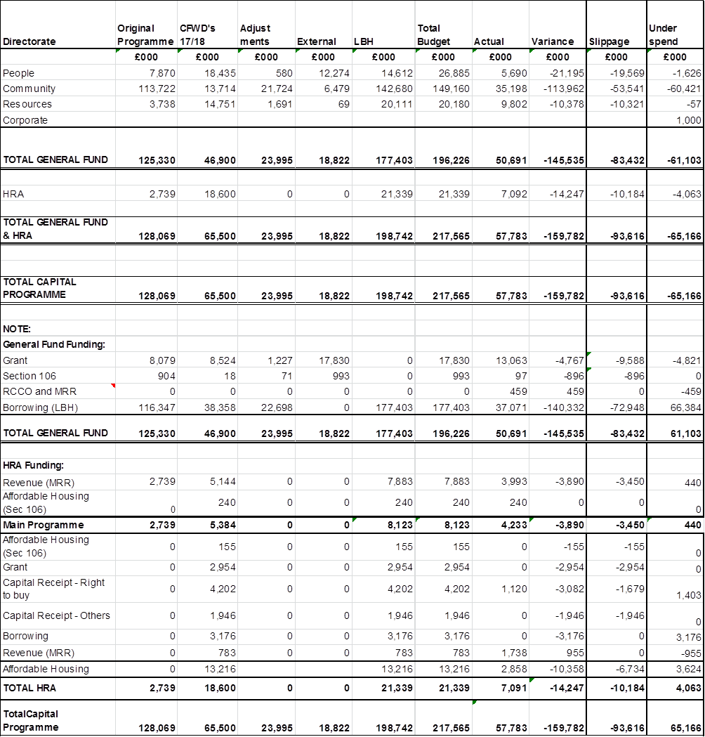

**DIRECTORATE PERFORMANCE ON CAPITAL**

1. The capital programme by directorate is included in Appendix 6 showing performance against the latest approved budget for each programme line. Set out below is narrative to explain the capital outturn and the major variances:

**Resources**

1. The directorate spent £9.802m against a budget of £20.180m, a 49% spend and a variance of £10.378m which will all be slipped to 2019/20. There are no revenue implications as a result of this slippage. The key reasons for slippage are listed below:

* Devolved Application (£2.315m) expenditure has been re-profiled to better reflect millstone delivery. The bulk of the work will be delivered in 2019/20.
* The on-going refresh and enhancement of ICT (£3.607m), the expenditure has been re-profiled to reflect delays in commissioning piece of work through 2018/19. The project must be delivered by 2019/20.
* ABAVUS (£1.099m), the slippage reflects planned expenditure in the second year (2019/20) of project delivery.
* SAP financial Ledger and System Control (£0.572m) will be slipped into 2019/20 in relation to the project to replace the current Enterprise Resource and Planning (ERP) system in 2019/20.
* Other Council Wide under spend (£1.9m) will be slipped into 2019/20.
* The remainder relates to numbers of smaller amounts which will be used to complete projects in 2019/20.

**Community**

1. The net position for the Community Directorate is an outturn of £35.198m against the budget of £149.160m, a 24% spend. The variance is £113.962m, £53.541m will be slipped to 2019/20 while £60.421m which relates mainly to the Regeneration main programme and Empty Property Grant is an under spend and the budget will be removed.

**Commissioning, Environmental Services**

1. The services spent £28.601m against a budget of £55.243m, a total variance of £26.642m, £26.529m is requested to be slipped into 2019/20 while £0.113m is the under spend that will be removed from the programme. The slippages relates mainly to the following projects. There is no revenue implication of these capital slippages.

* Depot redevelopment (£11.500m). The construction was delayed due to the re-submission of planning application due to the addition of additional floors on the development.
* Vehicle procurement (£13.500m). Due to lead in time, some vehicles on order are to be delivered in 2019/20.
* CCTV Infrastructure (£0.550m). This is a two year project. The procurement process is underway for the appointment of a suitable contractor for implementation in 2019/20.
* Redevelopment of Vernon Lodge (£0.400m). This is a multiple year’s project. Determination of the planning application was awaited as at year-end.
* Playground Improvement (£0.300m). The procurement was concluded and contract signed in March, and therefore the installation will take place in 2019/20.
* The remainder of the slippages (£0.279m) relates to smaller projects which are anticipated to be completed in 2019/20.
* The (£0.113m) underspend relates to the external funding re-alingment.

**Culture**

1. The services spent £1.062m against a budget of £2.026m. The variance is £0.964m, £0.978m is requested to be slipped into 2019/20 and £0.014m represents an over spend on the Harrow Art Centre roof work project.
2. The slippage relates mainly to the following projects. There is no revenue implication of these capital slippages.

* Bannister Sports Centre (£0.850m). The project is S106 funded. A funding application to the Football Foundation has been submitted to secure match funding for the installation of a 3G pitch and pavilion works. The outcome of the application is awaited, before the project is implemented in 2019/20.
* Libraries projects (£0.072m). Delays in completing priority health and safety works at Kenton Library due to the requirement for a listed building consent.
* New Central Library (£0.054m). This is a multiple year project with physical works on the fit out expected during 2019/20.

**Housing General Fund**

1. The service spent £2.473m against a budget of £18.688m, a 13% spend.
2. The variance is £16.215m; £15.258mwill be slipped to 2019/20 while £0.957m is no longer needed.
3. The main items of slippage are detailed below;

Additional Property Purchase Acquisition Programme

1. £15m slippage relates to acquisition of additional properties under the Council’s Property Acquisition Programme.Following a review of the performance of the first 100 properties approval has been granted to proceed with the additional properties which have resulted in the full budget being carried forward to be progressed in 2019/20. Although this has resulted in a temporary reduction in the supply of temporary accommodation, this initiative will assist the Council in alleviating GeneralFund homelessness pressures in accordance with the approved MTFS.

Other Housing General Fund projects

1. In 2018/19 £2.473m was spent against a budget of £3.688m. Of this variance of £1.215m, £0.258m of the variance has been slipped to 2019/20, with a net underspend of (£0.957m) on Empty Property Grants and improvement Grant. Within the under spend, £0.746m relates to budget set aside for Compulsory Purchase Order not now proceeding. There are no related revenue implications.

**Regeneration, Enterprise and Planning**

1. The net variance for the Regeneration, Enterprise and Planning Directorate is an outturn of £3.062m against the budget of £73.202m, a variance of £70.140m. (£10.776m of slippage and £59.364m underspend).

**Enterprise and Planning**

1. The service spent £0.760m against a budget of £1.785m. £1.023m is requested to be slipped into 2019/20 and relates to the following projects.

* Wealdstone Square (£0.300m). The project is in its implementation stage with construction work underway and completion expected in 2019/20.
* Mobile Technology (Adults Learning) (£0.050m). The service is in discussion with the GLA to utilise the funding for a virtual learning centre, however this is subject to final agreement.
* Neighbourhood CIL (£0.661m). This sum represents the unspent notional allocation in 18/19 capital programme.
* Lyon Road (£0.013m). This is an externally funded multiple year project with anticipated completion in 2020/21.

1. In 2018/19, the main regeneration programme spent £2.302m against a budget of £71.418m. Of the variance of £69.116m, £9.753m has been slipped to 2019/20 whilst £59.364m is underspent as a result of a revised capital programme set for 2 years from 2019/20 which accurately reflects current activity. This was reported to Cabinet in December 2018. There are no revenue implications as a result of this slippage.

**People Services**

1. The net position for People’s Service is an outturn of £5.690m against the budget of £26.885m, a 19% spend, with a variance of £21.195m. £19.569m of which is slippage and £1.626m is an under spend.

**Children’s Service**

1. The final outturn in 2018/19 for the schools capital programme is a total spend of £5.048m against a total budget of £25.573m. This represented expenditure of 20% against the budget. £19.243m of the variance has been slipped to 2019/20 and there is a net underspend on the capital programme of £1.282m.

**SLIPPAGE**

1. The reported slippage for 2018/19 is £19.243m. There are no revenue implications as a result of this slippage. The majority of these items are set out as follows;

* The majority of slippage relates to SEP2 primary, secondary & SEN schemes of £6.116m due to the ongoing contractual issues.
* £6.275m relates to funding set aside for secondary expansions. As reported to Cabinet in July 2018 the projections for Year 7 places continue to show a lower trajectory of increase than the 2015 projections. With the current number of places available there will be a shortfall of 2 forms of entry in 2021/22 and peaks at up to 5 forms of entry in 2022/23. However, at this time there are a higher number of Year 7 places than required which is resulting in vacancies being concentrated in a small number of schools. It is proposed to slip the funding to 2020-21 and ensure that the situation is monitored and that once there is greater clarity about changes on the borough boundaries that a local solution to meet the growing need is developed with the High Schools.
* Special Educational Needs provision slippage totals £3.495m. Funding has been included in the capital programme to support additional in-borough SEND provision will be delivered in line with the SEND Strategy reported to Cabinet in February 2019.
* £2.625m relates to funding set aside for secondary expansions. As reported to Cabinet in June 2017 the projections for Year 7 places continue to show a lower trajectory of increase than the 2015 projections. With the current number of places available there will be a shortfall of 4 to 5 forms of entry in 2022/23. This reduces to 3-5 forms of entry in 2027/28. However, at this time there are a higher number of Year 7 places than required which is resulting in vacancies being concentrated in a small number of schools. It is proposed to slip the funding to 2019-20 and ensure that the situation is monitored and that once there is greater clarity about changes on the borough boundaries that a local solution to meet the growing need is developed with the High Schools.
* The remainder of the slippage is for IT and funding for bulge classes and amalgamations which were not needed this financial year.

**Secondary Expansion Programme 1 and 2 including Secondary and SEN**

1. Engie (formerly Keepmoat), the Council’s Framework Partner was commissioned to deliver the majority of the Phase 1 (SEP1) and Phase 2 (SEP2) construction projects. The projects in SEP1 and SEP2 have reached Project Completion and the schools are occupying their new accommodation. The directorate is working to resolve a number of building defects with Engie post completion. There are on-going contractual issues with Engie and the council has appointed Legal and Commercial advisers to secure resolution.

**Adult Services**

1. The service spent £0.604m against a budget of £1.138m, a 53% spend, with a variance of £0.535m, £0.191m relating to slippage and a £0.344m net under spends. The slippage relates to the following:

* Integrated Health Model £0.085m slippage, whilst this project has been finalised, the under spend is being carried forward to enable flexibility to support the Adult Social Care transformation programme during 2019/20 should this be necessary.
* House Residential £0.106m - plans for improvements in place, the majority of which relate to Mailman’s for roof and floor works which were being developed during 2018/19 together with other remodelling as appropriate to maximise service delivery.
* The net underspend of £0.344m relates to Project Infinity which is no longer required given that the project ceased in April 2019.

**Public Health**

1. The service had been given Healthy Pupils Capital Fund ring fenced grant of £0.174m for the Water Fountain Project of which £0.039m has been spent with the balance £0.135m slipped into 2019/20 for expenditure committed.

**Housing Revenue Account**

1. HRA spent £7.092m against a budget of £21.339m, including Homes-4-Harrow, a spend of 33%. £10.184m will be slipped to 2019/20 leaving a £4.063m under spends against the programme.
2. The main items of slippage is detailed below:
3. With regard to Homes-4-Harrow, £6.114m slippage relates to Grange Farm which now has planning permission and is moving into the procurement phase, and £0.620m relates to the phase 1 of the Infill programme, which is required to complete the scheme. Financing for all schemes in the HRA is being reviewed as part of the planned HRA Business Plan refresh which will be reported to Cabinet.
4. £3.450m slippage relates to the main Planned Investment programme which prioritises health and safety and compliance works. Of this balance £1.110m has been identified to fund the Housing IT replacement system and set up a client contingency for the New Council House Building programme.
5. The under spend relates to the following:

* Phase 2 of the Infill program (£3,625m) - This programme did not commence in 2018/19 due to the withdrawal of borrowing approval by MHCLG. Separate budget provision has been identified in 2019/20; hence this budget is no longer required.
* Planned investment programme, (£0.438m). The costs for works came in lower than expected which have resulted in this underspend.

1. **TIMETABLE FOR PREPARATION OF DRAFT STATEMENT AND EXTERNAL AUDIT REVIEW.**
2. All Local Authorities must now have their draft statutory Statement of Accounts published by 31st May each year and the audit opinion issued by 31st July. The Accounts were published by the 31st May deadline and the audit is in progress.
3. **IMPLICATIONS OF THE RECOMMENDATIONS**

The recommendations are asking the Cabinet mainly to:

* To note the revenue and capital outturn position for the 2018/19
* To note the movement between reserves
* To note the revenue carry forwards
* To note the slippages on the Capital Programme
* To note the Quarter 4 Commercialisation Update as specified in Appendix 5.

These recommendations do not affect the Council’s staffing / workforce and have no equalities, procurement, data protection or community safety impact.

6**.0 Ward Councillors’ comments**

1. **PERFORMANCE ISSUES**

Financial performance is considered quarterly to Cabinet.

**8.0 ENVIRONMENTAL IMPACT**

There is no direct environmental impact

**9.0** **DATA PROTECTION IMPLICATION**

There are no data protection implications

1. **RISK MANAGEMENT IMPLICATIONS**

The Key financial risks are managed through the risk management strategy. There is one significant financial risk currently included on the Corporate Risk Register:

Risk 1 - Inability to provide services within budget. This risk is currently rated at B1, High Likelihood/Catastrophic Impact.

**11.0 PROCUREMENT IMPLICATIONS**

There are no procurement implications arising from this report

1. **LEGAL IMPLICATIONS**

Section 151 of the Local Government Act 1972 states that, “without prejudice to section 111, every local authority shall make arrangements for the proper administration of their financial affairs and shall secure that one of their officers has responsibility for the administration of those affairs”

Section 28 of the Local government Act 2003 imposes a statutory duty on a billing or major precepting authority to monitor, during the financial year, its income and expenditure against budget calculations.

Under B66 of the Financial Regulations, a year-end balance is the amount by which actual income and expenditure varies from the final budget, normally identified down to budget manager level. Unspent balances will not be carried forward, except with the permission of the CFO. Unspent balances will only be considered for carry forward where;

* There is an unspent ring fenced grant and grant must be repaid if it is not spent on its intended purpose.
* Funding has been allocated to a specific project and the project is not yet complete, and both the directorate and the Council in total are not overspent.
* External funding has been received for a specific project which is not yet complete.

1. **FINANCIAL IMPLICATIONS**

Financial implications are contained within the body of the report.

1. **EQUALITIES IMPLICATIONS / PUBLIC SECTOR EQUALITY DUTY**

There is no direct equalities impact.

The MTFS savings have had equality impact assessments completed on them where required and these have been published with the budget setting report.

**15.0 CORPORATE PRIORITIES**

The Council’s Outturn Report for 2018/19 has been prepared in line with the Council’s vision:

**Working Together to Make a Difference for Harrow**

* Making a difference for the vulnerable
* Making a difference for communities
* Making a difference for local businesses
* Making a difference for families

**Section 3 - Statutory Officer Clearance**

|  |  |  |  |
| --- | --- | --- | --- |
|  |  |  |  |
| Name: Dawn Calvert | x |  | Director of Finance |
| Date: 7/06/2019 |  |  |  |
|  |  |  | on behalf of the |
| Name: Chris Cuckney | x |  | Monitoring Officer |
| Date: 11/06/2019 |  |  |  |
|  |  |  | on behalf of the |
| Name: Nimesh Mehta | x |  | Head of Procurement |
| Date: 23/05/2019 |  |  |  |

|  |  |  |  |
| --- | --- | --- | --- |
|  |  |  |  |
| Name: Charlie Stewart | x |  | Corporate Director |
| Date: 11/06/2019 |  |  |  |

|  |  |
| --- | --- |
| Ward Councillors notified: | NO |
| EqIA carried out:  EqIA cleared by: | NO  N/A |

# Section 4 - Contact Details and Background Papers

**Contact:** Sharon Daniels (Sharon.daniels@harrow.gov.uk)

**Background Papers:**

|  |  |  |
| --- | --- | --- |
| Call-In Waived by the Chair of Overview and Scrutiny Committee |  | **NOT APPLICABLE**  *[Call –in applies]* |